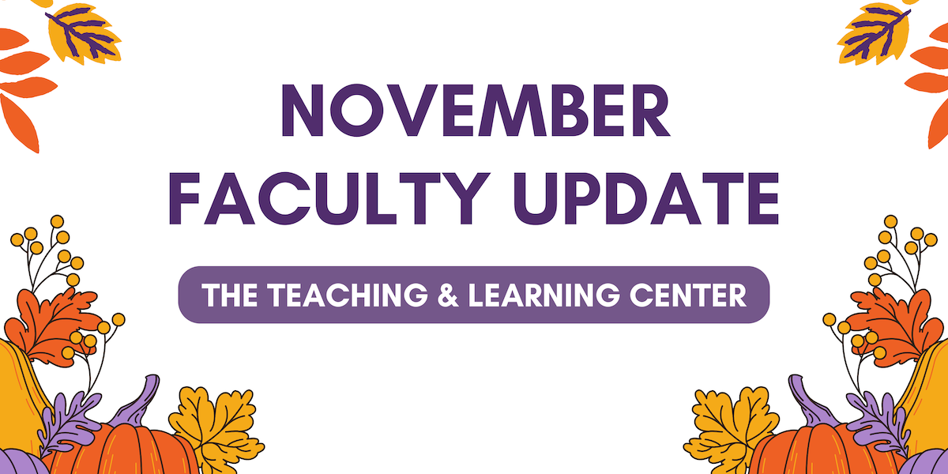

# Open Calls & Initiatives

## (Due Nov 24) Faculty Fusion 2025: Calling Interested Panelists & Moderators

[Faculty Fusion](https://wcu-tlc.org/pd/2025-faculty-fusion-hot-topics-with-the-tlc/) will return to the Foundation on January 15, 2025 with three new topics to kick off the spring semester:

1. Fostering Student Agency, Ownership, and Leadership
2. Innovative Teaching, Impactful Research: Transforming Classroom Practices into Scholarship
3. Matching Accommodations to Reality - Strategies to Help Faculty meet Student Needs

Are you interested in being a faculty panelist or moderator for one of our topics? Complete the [call for interest form](https://wcupa.co1.qualtrics.com/jfe/form/SV_0DK1sgxpkpdQ2IC) by **Sunday, November 24**, and a member of the TLC staff will reach out to learn more about your expertise and ideas.

## (Due Nov 24) Spring 2025 Student-Faculty Teaching Collaborations Program

Are you interested in getting student feedback and perspectives on your teaching practices? Do you want to boost your teaching confidence or reignite your passion for teaching? If so, consider participating in the [Student-Faculty Teaching Collaborations Program](https://www.wcupa.edu/tlc/student-faculty-collab.aspx) during the Spring 2025 semester! This program pairs you with two WCU students who will provide frequent and varied feedback on one of your courses from their perspective.

To learn more, [visit our website](https://www.wcupa.edu/tlc/student-faculty-collab.aspx), or to apply, review the [Student-Faculty Teaching Collaborations Call for Applications](https://wcupa.co1.qualtrics.com/jfe/form/SV_cLMrRwBREjOeV70). Applications are due **Sunday, November 24**.

## (Due Dec 2) Faculty Survey: Open Educational Resources at WCU

As the cost of textbooks and other educational materials continues to rise, faculty have been turning to [Open Educational Resources (OER)](https://www.wcupa.edu/tlc/oer.aspx) as a solution to keep student costs down and bring equity to their courses, and the Teaching & Learning Center and University Libraries currently offer a variety of programs, resources, and services to faculty who are interested in OER.

To inform our decisions about future OER-related efforts, the TLC and University Libraries are working together to create and distribute a [survey to better understand how WCU faculty use, create, and adapt these materials](https://wcupa.co1.qualtrics.com/jfe/form/SV_2oipSY4e1IJZqui). The survey will close on **Monday, December 2.** To learn more, visit [the TLC blog](https://wcu-tlc.org/etextbook/faculty-survey-open-educational-resources-at-wcu/).

## (Due Jan 31) Teaching Triangles for the Spring Semester

The Teaching Triangles program involves three faculty members in a triad who agree to visit each other’s classes over the semester and meet to discuss what they have learned about their own teaching from the observations. The process is non-evaluative, and the program is open to all WCU faculty, including adjuncts. Learn more about the program [on our website](https://www.wcupa.edu/tlc/flc.aspx) or [from our podcast, ODLI on Air](https://open.spotify.com/episode/7EVYwGZvoqtNBIDy4jiaDa?si=w5eFVVtcRCW6k0ulgMs-rw&nd=1&dlsi=7e683d93f8334283). If you're interested, [apply online](https://wcupa.co1.qualtrics.com/jfe/form/SV_02LR8pktqgLt5ye) by **January 31, 2025.**

## (Ongoing) Willing to Share Your Experience Working with Generative AI?

The TLC is looking for individuals interested in delivering 15 minute, recorded webinar presentations connected to one of these four themes:

1. Getting started with Generative AI tools
2. Academic honesty and what original work means in your discipline
3. Creating an AI policy with students
4. Building real world assignments in an AI age

Complete our [interest form](https://wcupa.co1.qualtrics.com/jfe/form/SV_1YVWtISHaJVHo22) and a member of the TLC will be in touch. If you have any questions, please contact us at [tlc@wcupa.edu](mailto:tlc@wcupa.edu?subject=).

# Upcoming Events

## (In-person: Nov 11) Join Us for the Fall 2024 Tech Talk!

**When:** Monday, November 11 from 12:00pm to 1:00pm

**Where:** Anderson Hall, Room 125

Light refreshments will be provided.

The goal of Tech Talk is to bring together faculty across different departments on campus to share their innovative uses of technology in teaching and learning, and to exchange ideas. During this Fall 2024 offering, Nursing Department Chair and Associate Professor, Dr. Nancy Barker, will share how she is using VTS Editor to create interactive learning activities that boost student engagement and comprehension.

If you're interested in attending, please RSVP via the [Fall 2024 Tech Talk Form](https://wcupa.co1.qualtrics.com/jfe/form/SV_804yGBdi4pJt3U2)at your earliest convenience. If you have any questions about this offering, please contact Jessica Drass at [jdrass@wcupa.edu](mailto:jdrass@wcupa.edu?subject=).

## (Virtual: Nov 13) A Virtual Visit from Devon Price

Devon Price, author of *Unmasking Autism*, will visit West Chester University virtually on **Wednesday, November 13** from 12:00 - 1:00pm for a Q&A style conversation! The event is available virtually via Zoom and will be streaming in Main 200, where free pizza will be offered. Whether you are attending virtually or in person, please [sign up in advance](https://wcupa.zoom.us/webinar/register/WN_oqbtKKGOQR-nELwRdnAHVw?_x_zm_rtaid=qG15FID9QoS5RXn1GMFYcw.1730987188032.4e1bc327139a23a5a177030626675cdd&_x_zm_rhtaid=888#/registration).

This free event is open to anyone who wants to join, and reading the book is not a requirement for participation. If you have questions or technological difficulties, please contact Jacqueline Alnes ([jalnes@wcupa.edu](mailto:jalnes@wcupa.edu?subject=)).

## (In-person: Dec 10 – 12) You Have to Try AI Before You Guide AI

Are you looking for some dedicated time to explore generative AI tools? If so, join TLC staff for an hour (or more) during finals week to play in the proverbial AI sandbox in Anderson 125. We will explore tools such as ChatGPT, Microsoft CoPilot, Claude, Google LM notebook, Perplexity, Sonora, and more. Bring your laptop and any AI tools you want to try!

Sessions occur at 10 am, 11 am, 1pm and 2pm on:

* **Tuesday, December 10**
* **Wednesday, December 11**
* **Thursday, December 12**

[Pre-registration](https://wcupa.co1.qualtrics.com/jfe/form/SV_0GwF6kget8RyLxY) is appreciated, but not required.

## (In-person: Dec 16) Applying the Quality Matters Rubric (APPQMR) Workshop

This full day, in-person workshop will renew your CAPC Distance Education Training Credential and award you the official Quality Matters APPQMR Certificate of Completion. It is facilitated by WCU instructional designers. The training will be held on **Monday, December 16** from 8:30am to 4:00pm; participants must attend the whole day. Complete the [APPQMR Interest Form](https://wcupa.co1.qualtrics.com/jfe/form/SV_8kn2OJpAqrkfi4u), and a member of the TLC will be in contact a few weeks prior to the workshop with location information. Space is limited.

## (In-person: Jan 15) Faculty Fusion 2025: Save the Date!

Save the date for [Faculty Fusion](https://wcu-tlc.org/pd/2025-faculty-fusion-hot-topics-with-the-tlc/)!

* **When:** **January 15, 2025** from 9:00 am to 1:00 pm
* **Where:** The Foundation
* **What:** An in-person set of three interactive panels covering hot topics to help you prepare for the new semester.

Panel topics include:

1. Fostering Student Agency, Ownership, and Leadership
2. Innovative Teaching, Impactful Research: Transforming Classroom Practices into Scholarship
3. Matching Accommodations to Reality - Strategies to Help Faculty meet Student Needs

Each session has 30 minutes of presentation from a faculty panel followed by 20 minutes of Q&A and table conversations with your peers. Watch this space for registration details, or reach out to [tlc@wcupa.edu](mailto:tlc@wcupa.edu?subject=) with any questions.

## Coming Soon: Quality Matters Summer Camp

In an effort to streamline the Quality Matters course review and certification process, we are consolidating our year-long initiative into a three-week QM Summer Camp from **June 2 to June 20, 2025**. This streamlined model will facilitate collaboration within a cohort, consolidate the work to prepare your course, and allow you to focus on your teaching during the academic year. At the end of summer camp, you can have one course ready for a Quality Matters course review. Faculty who earn QM certification are eligible for a stipend. More information and applications to come in Spring 2025.

# Program Updates

## PA-ADOPT: New eTextbook Published

The [PA Alliance for Design of Open Textbooks](https://paadopt.org/) is pleased to announce the immediate availability of our ninth free and open eTextbook: [*The Digitial Storytelling Handbook*](https://paadopt.org/bookshelf/the-digital-storytelling-handbook/) by Dr. Jordan Schugar, Professor of English, and Dr. Chris Penny, Professor of Educational Foundations & Policy Studies, at West Chester University (WCU). Other contributors include Hannah Glatt, Learning Experience and eTextbook Designer, and Autumn Hudson, Tu Le, Sarah Mangano, and Victoria McQuiston, Graduate Students at WCU. To learn more, [check out our blog](https://wcu-tlc.org/etextbook/new-etextbook-the-digital-storytelling-handbook/)!

## Online Faculty Development Program

Need to earn or renew your CAPC distance education credential? Faculty can now self-enroll into the OFD program’s D2L site using the [Discover feature](https://wcupaprod.service-now.com/kb?id=kb_article_view&sysparm_article=KB0010869)! Start working whenever it fits your schedule.

# Stay Connected

## Discover the TLC Blog

Dive into a wealth of resources designed to enhance your teaching and learning experience! Our blog features the [latest event information](https://wcu-tlc.org/category/pd/), [insightful podcast episodes](https://wcu-tlc.org/category/podcast/), and engaging posts from [faculty](https://wcu-tlc.org/ai/ai-source-project-students-writing-about-ai/) and [staff](https://wcu-tlc.org/course-design/preparing-for-challenging-discussions-in-the-classroom-with-community-agreements/) on a variety of teaching topics. Whether you're looking for innovative strategies, inspiration, or community insights, the [TLC Blog](https://wcu-tlc.org/) is your one-stop shop for all things teaching.

## Connect with Us

The Teaching and Learning Center is far more than just a newsletter! Our website hosts a variety of [teaching resources](https://www.wcupa.edu/tlc/teaching-resources.aspx) and our full [Event Calendar](https://www.wcupa.edu/tlc/events.aspx). To get in touch, feel free to [send us an email](mailto:tlc@wcupa.edu?subject=), or stop by our [drop-in hours](https://www.wcupa.edu/tlc/drop-in.aspx) to speak live with one of our designers.