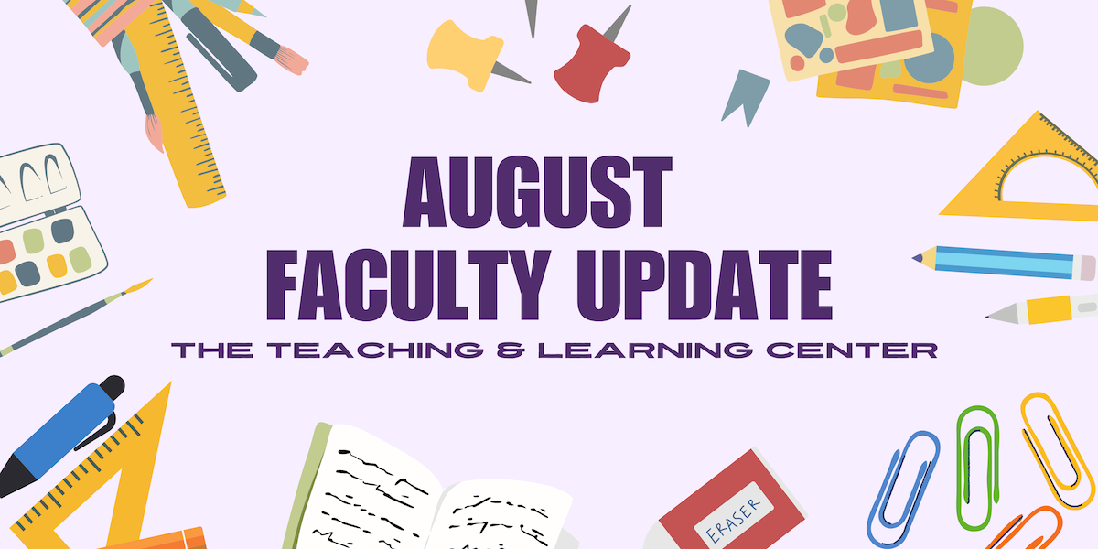

Welcome back to campus! As another academic year starts up, we at the Teaching & Learning Center are thrilled to share all the new opportunities and resources we’ve curated just for you. Remember, our instructional designers are always here to help: if you need support getting the ball rolling for the Fall semester, don't hesitate to reach out or [drop in](https://www.wcupa.edu/tlc/drop-in.aspx)!

# Open Calls & Initiatives

## (Due Aug 30) Program for Excellence in Teaching & Learning (PETAL)

PETAL (Program for Excellence in Teaching and Learning) invites you to participate in a semester-long experience! Join fellow educators in weekly conversations and reflections on teaching excellence. This program, sponsored by the Provost, is open to all incoming faculty and a limited number of current faculty members. [Learn more about PETAL](https://www.wcupa.edu/tlc/petal.aspx) on our website. Applications are due by **Thursday, August 30.**

## (Due Sep 6) Fall 2024 Teaching Circles

A teaching circle is a group of faculty who collectively explore a teaching topic of interest and work together to create a product reflecting their learning experience. The group collaboratively determines what product or products they wish to create at the start of the process.

This Fall semester, two teaching circles are forming: Generative Artificial Intelligence and Science of Learning. To learn more or sign up, see the [full program description](https://www.wcupa.edu/tlc/flc.aspx) on our website.

## (Due Sep 20) 2024-25 Diversity & Inclusion Faculty Learning Community

We invite all faculty members who are interested in improving their inclusive teaching methods and promoting equitable learning outcomes to apply for the 2024-25 Diversity and Inclusion Faculty Learning Community (DI FLC). By participating in the FLC, you will join a multidisciplinary group of faculty members who will collaborate to explore and enhance equitable and inclusive teaching practices. Our goal is to create supportive and inclusive learning environments where all students feel a strong sense of belonging. To learn more, please visit the [FLC website](https://www.wcupa.edu/tlc/flc.aspx), or [submit your application](https://wcupa.co1.qualtrics.com/jfe/form/SV_a4s1LgebuZ0e21M) today! Questions can be directed to Dr. Kimberly E. Johnson ([kjohnson4@wcupa.edu](mailto:kjohnson4@wcupa.edu?subject=)).

## (Fall 2024) CELT Book Club

It’s time to [register for the Committee for Excellence in Learning and Teaching’s Fall 2024 Book Club](https://docs.google.com/forms/d/e/1FAIpQLScEPHR1JEYQpujuGM70jrqGDQecScFKvZgIl_P0C06PQbln-Q/viewform)! We invite you to join CELT in reading and discussing José Antonio Bowen and C. Edward Watson’s [*Teaching with AI: A Practical Guide to a New Era of Human Learning*](https://www.press.jhu.edu/books/title/53869/teaching-ai) (2024). To participate and receive a complimentary copy of the book, you must commit to attending two meetings throughout the semester: one in October and one in November.

After [registering online](https://docs.google.com/forms/d/e/1FAIpQLScEPHR1JEYQpujuGM70jrqGDQecScFKvZgIl_P0C06PQbln-Q/viewform), you may pick up your copy from the Teaching and Learning Center on Tuesdays or Thursdays starting on August 6. If you have any questions, please contact book club leaders Dawn Patterson ([dpatterson@wcupa.edu](mailto:dpatterson@wcupa.edu?subject=)) and Jenn Raskauskas ([jraskauskas@wcupa.edu](mailto:jraskauskas@wcupa.edu?subject=)).

# Upcoming Events

**(Virtual: Sep 10) Proactive Accessibility: Minimizing Accommodation Requests through Inclusive Course Design**

Have you noticed an increase in student requests for accommodations in your courses? You’re not alone! Join the OEA and the TLC on **Tuesday, September 10** at 2:00pm for a workshop to explore effective strategies for supporting students with diverse learning needs and designing courses that minimize the need for individual student accommodations. This workshop is co-sponsored by the Faculty Ombuds Office. [Register for the Proactive Accessibility workshop today!](https://wcupa.co1.qualtrics.com/jfe/form/SV_3RfSR0iIOAbivjM)

## (Virtual: Sep 11) Designing for Equity: Using UDL to Create an Equitable & Inclusive Classroom

Join the TLC staff on Zoom on **Wednesday, September 11** at 2:00pm for a flexible format workshop to discuss the principles of Universal Design for Learning (UDL) to design equitable and inclusive classrooms. Our goal is to allow faculty to tailor the experience to their own knowledge, experience, and goals. Are you new to UDL? Do you want to improve your courses in one of the three UDL areas? We’ll have instructional designers on hand to work with you on what matters most to you. [Register for the Designing with Equity workshop today!](https://wcupa.co1.qualtrics.com/jfe/form/SV_9tsATg521x17eh8)

## (Virtual: Sep 12) Teaching Neurodiverse Learners

Join DCAP and the TLC on **Thursday, September 12** at 2:00pm for a workshop exploring effective strategies for supporting neurodivergent students and managing a neurodiverse classroom. [Register today!](https://wcupa.co1.qualtrics.com/jfe/form/SV_8uMnkh8GxRekf1c)

## (Virtual: Sep 18) Strategies for Facilitating Dialogue

This 90-minute workshop will offer resources and strategies for faculty and staff available through the Constructive Dialog Institute (CDI) platform, such as identifying constructive open-ended questions for challenging conversations, modeling reflective and active listening, and developing ready responses for unpredictable moments inside or outside of the classroom. Our facilitators will be Dr. Joan Woolfrey and Helen Hammerschmidt.

[Register today](https://wcupa.co1.qualtrics.com/jfe/form/SV_3rfe6ALLU9gJHw2) for the virtual session on **Wednesday, September 18** at 1:00pm for the in-person session on Tuesday, October 2!

## (Virtual: Sep 25) Teaching in Turbulent Times

As a University that values diversity and inclusion, how can you ensure that our classrooms and other learning environments are places for civil discourse and respectful disagreement? This discussion will allow faculty and staff to explore this issue by examining case studies and proactively plan for these moments. This workshop was created by Dr. Tracey Robinson and is designed for participants to explore strategies for maintaining civil discourse and respectful disagreement in the classroom during contentious moments. Dr. Robinson will facilitate alongside Dr. Janneken Smucker.

[Register today](https://wcupa.co1.qualtrics.com/jfe/form/SV_3rfe6ALLU9gJHw2) for the virtual session on **Wednesday, September 25** at 1:00pm for the in-person session on Tuesday, October 8!

# Program Updates

## Technology Roundup – Fall 2024

The Technology Roundup is a blog feature that is released each Fall and Spring semester to keep our community of educators informed on the latest available instructional technologies that are supported by the university. Check out the [Fall 2024 edition](https://wcu-tlc.org/instructional-technology/technology-roundup-fall-2024/)!

## New D2L Course Design Resources Site

We are pleased to announce the launch of the D2L Course Design Resources Site, which is now available for all WCU faculty. This site is hosted in D2L and is designed to support course creation and enhancement efforts by providing easy access to essential tools and templates. The site currently includes:

1. **A Library of Pre-Designed D2L Homepage Templates:** These customizable templates can be copied to any course to help instructors set up a professional and engaging course homepage quickly and efficiently
2. **Creator+ Resources:** Creator+ is a new tool available in D2L that allows instructors to easily add dynamic content and interactive activities directly to their course module pages.

You can access the D2L Course Design Resources Site from the Resources tab on the homepage of D2L, or by following this link: [D2L Course Design Resources Site](https://d2l.wcupa.edu/d2l/home/3691882). If you have any questions about the D2L Course Design Resources Site, please contact the TLC at [tlc@wcupa.edu](mailto:tlc@wcupa.edu).

## New Netiquette Resource for WCU Courses

The TLC is pleased to announce the development of a new, updated [Netiquette explanation](https://wcu-tlc.org/instructional-technology/netiquette/)! This document provides brief explanations of each concept introduced, as well as citations. We invite all faculty to provide this document as a resource in your online courses to help students understand what is expected of them when engaging in online dialogues. The updated version replaces the [old Netiquette document,](https://www.wcupa.edu/distanceEd/documents/BestPracticesStudentNetiquette.pdf) which will be retired on **July 1**: if there are any links to the old document in your courses or syllabi, be sure to update them in advance to prevent confusion.

## New eTextbook: *Introduction to World Philosophies*

Congratulations to Paul Harris, Instructor of Philosophy and participant in the Teaching & Learning Center’s eTextbook Initiative, for completing his new electronic textbook, *Introduction to World Philosophies.* Paul’s book, which replaces a $105 commercial textbook, will be provided to WCU students for free and used in PHI 101 - Introduction to Philosophy. To learn more, [check out our blog](https://wcu-tlc.org/etextbook/new-etextbook-introduction-to-world-philosophies/)!

## Online Faculty Development Program

Need to earn or renew your CAPC distance education credential? Faculty can now self-enroll into the OFD program’s D2L site using the [Discover feature](https://wcupaprod.service-now.com/kb?id=kb_article_view&sysparm_article=KB0010869)! Start working whenever it fits your schedule.

# Stay Connected

## ODLI on Air Podcast

Season 5 kicks off Wednesday with “Podcasts as Class Texts with Dr. Anne Gill!” New episodes of 30 minutes or less release every other week during the semester, but if you need more right away, you can also check out the [44 episodes in the ODLI on Air catalog](https://open.spotify.com/show/7dlveEuHbzzJ9BfgotUyq8).

Are you interested in being a guest on the podcast? If so, email us at [tlc@wcupa.edu](mailto:tlc@wcupa.edu).

## Connect with Us

The Teaching and Learning Center is far more than just a newsletter! Our website hosts a variety of [teaching resources](https://www.wcupa.edu/tlc/teaching-resources.aspx) and our full [Event Calendar](https://www.wcupa.edu/tlc/events.aspx). To get in touch, feel free to [send us an email](mailto:tlc@wcupa.edu?subject=), or stop by our [drop-in hours](https://www.wcupa.edu/tlc/drop-in.aspx) to speak live with one of our designers.