College of Arts & Humanities

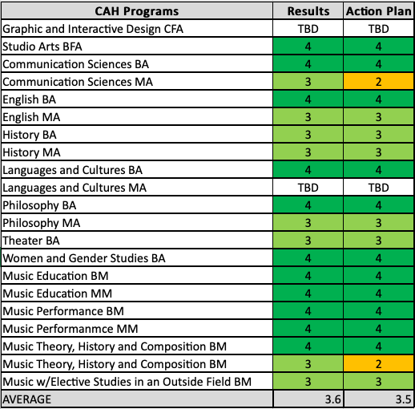
*TBD indicates a new program/assessment plan in development.
College of Business and Public Management

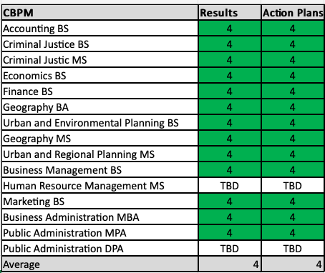
*TBD indicates a new program/assessment plan in development.
College of Health Sciences

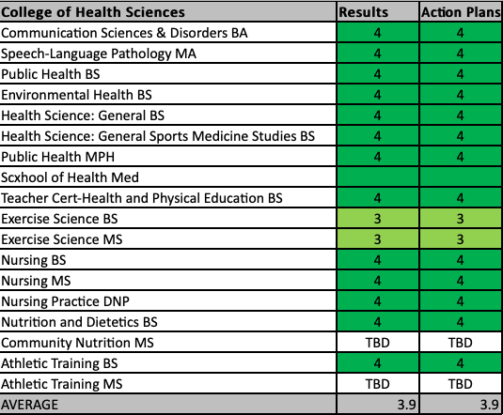
*TBD indicates a new program/assessment plan in development.

College of Sciences and Mathematics

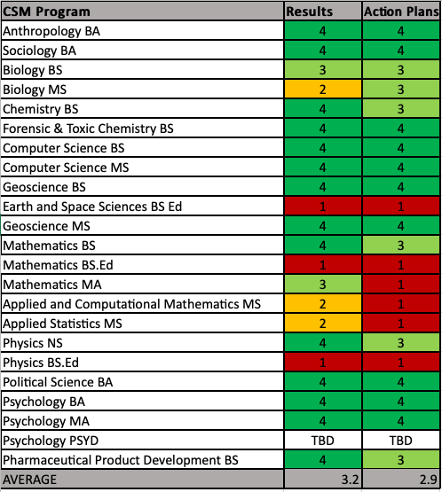
*TBD indicates a new program/assessment plan in development.

