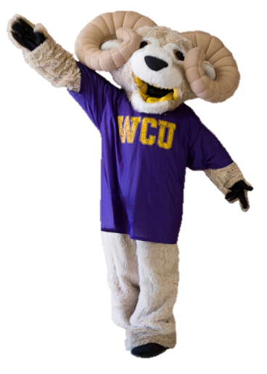

Thank you for your feedback in taking the Faculty Survey of Student Engagement (FSSE) to tell us about your WCU experience. Let your voice be heard in 2014, complete the FSSE!

You said: Over 90% of faculty indicate that discussing career interests is an important component of being an advisor.

We answered: The TLA Center and Office of Distance Education is providing lunch on 4/16/14 to discuss how to use these tools to improve teaching and learning in the face to face class. Email [agrinwis@wcupa.edu](mailto:agrinwis@wcupa.edu) to reserve your spot!

You said: 50% of faculty indicated they never use mobile computing devices within their classrooms.

We’ve Heard Your Voice… And Are Taking Action!

We answered: The Council on Undergraduate Research has been formed and developed a month-long summer research experience to enable more faculty –student collaboration. [www.wcupa.edu/research](http://www.wcupa.edu/research)

You said: Only 50% of faculty indicated they engage in faculty student research.

We answered: The Career Development Center subscribed to the online database: ‘What Can I Do With My Major?’ to help identify the connections between occupations and a students’ major. Share this database with advisees <http://www.wcupa.edu/_SERVICES/STU.CAR/default.asp>