The Department of Political Science Alumni Awards - 2025
The Department of Political Science Alumni Award Committee solicits nominations for the awards from all members of the broader West Chester University community. The committee reviews the materials submitted on each candidate and selects those candidates who are deemed most deserving of recognition and whose achievements most closely fit the category for which they have been nominated.
Distinguished Alumni Award
This award recognizes an alumnus/alumna with exemplary (quality and depth of) achievements over the span of a professional career. This award recognizes those who have had extraordinary success in the following arenas: professional achievement, public service, community involvement, and advancement of the University’s mission.

Outstanding Young Alumni Award
The Outstanding Young Alumni Award honors the achievements of more recent graduates up to the age of forty. This award spotlights leaders who have demonstrated early success in their professional community and show continued potential in their profession, commitment to their community and dedication to West Chester University.
Nomination Form/Process
A nomination should consist of a letter outlining the reasons the submitter thinks the nominee is an exceptional candidate and an outline of the nominee’s professional accomplishments. The nomination may include details about the nominee's career, recognitions or honors, publications, civic and philanthropic activities and any other germane information and how they fulfill the award criteria. Supporting materials are encouraged. All nominations will be kept strictly confidential.
The nominating period starts March 4th. Deadline for receiving nominations is April 4th, 2025. Anyone may submit a nomination for an alumni award. Nominations are reviewed by a selection committee made up of members of the Department of Political Science.
Awards will be presented at an Alumni Awards event in April each year and will likely coordinate with the University’s larger Alumni Weekend!
You may submit a nomination and supporting materials online (Word document) to Ms. Megan Beachy at MBeachy657@wcupa.edu . Any questions may also be directed to Ms. Megan Beachy.
Previous Award Winners:
- Distinguished Alum: Honorable Judge Barry Dozor (2022); PA State Representative Tim Briggs (2023); Amy Yovziak (2024) and Dr. Josuha Weikert (2024)
- Young Alum: Laura Ness and John O’Brien (2022); Chuck Liedike and Ikedi Onyemaobim (2023); William Ferrell (2024)

Information about Nominee: (Letter of Support)

Sincerely,
[Your Name]
You may send/upload any additional support items like the person’s resume/CV or any other relevant supporting information.


Department of Political Science WCU Alumni AWArd Nomination
  - Form
A nomination should consist of a letter outlining the reasons the submitter thinks the nominee is an exceptional candidate and an outline of the nominee’s professional accomplishments. The nomination may include details about the nominee's career, recognitions or honors, publications, civic and philanthropic activities and any other germane information and how they fulfill the award criteria. Supporting materials are encouraged. All nominations will be kept strictly confidential.
The nominating period starts March 1st. Deadline for receiving nominations is April 4th, 2025. Anyone may submit a nomination for an alumni award. Nominations are reviewed by a selection committee made up of members of the Department of Political Science. You may submit a nomination and supporting materials online (Word document) to Ms. Megan Beachy at MBeachy657@wcupa.edu . Any questions may also be directed to Ms. Megan Beachy.

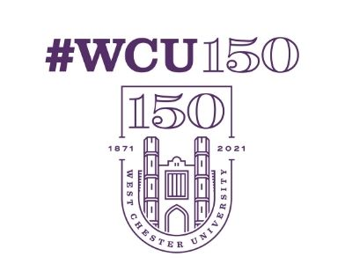 |  |  | Name of Nominee:  Graduation Year:  Contact Information:  (Email, Cell, Address)  Award: (Check box) Distinguished □ or Outstanding Young □  Name of Nominator:  Title/Position:  Contact Info (email):
You may send/upload any additional support items like the person’s resume/CV, a separate letter of support, or any other relevant supporting information.

