Building the Foundation of Earthquakes:
An Exposition on Ordinary Differential Equations
West Chester University of Pennsylvania
By Paul Johnson

Introduction
This project investigates various types of Ordinary Differential Equations that model the displacement of floors in a structure. Using the principles of the spring mass system, the models are further developed to incorporate dynamic behavior between floors and outside forces. Earthquakes are a dynamic load that can create damaging deformations. To prevent damage, buildings need to be constructed in a way that reduces rapid movement from floor to floor. The level of damage that can be prevented is segregated by the stiffness, strength, and ductility of the structure. To learn the of impact seismic waves, it is important to investigate the motions and natural frequencies of the building. Although these models can become greatly complicated, they are the foundation of structural dynamics and earthquake engineering. In order to prevent damage and improve upon structural safety, the study of mathematical simulations is needed.
Background
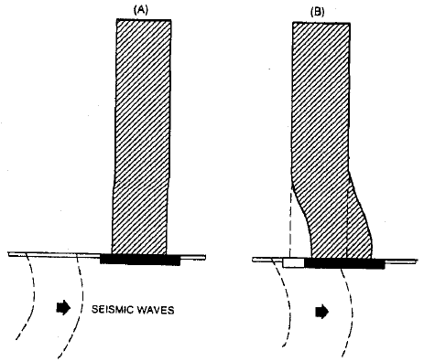
Figure 1 Visualization of seismic disturbances (Ghosh 2003:41)
Earthquakes cause the foundation of buildings to move in the motion of the ground, as seen in fig. 1. For a structure to survive an earthquake, it must disperse the energy of the distortions caused by the earthquake. The effect of this motion is amplified by the exciting motion, or accumulated displacement from floor to floor (Chopra 2009:1). There are other forces considered with building design. Wind, for example, is an external force that applies load proportional to the surface. Earthquakes are effected directly by the mass of the structure, rather than the surface. Although it may be assumed a heavier, stiffer building would allow the least displacement against wind, it may not prove a conducive design against earthquakes.
In fig. 2 below, there are examples of different seismic disturbances:
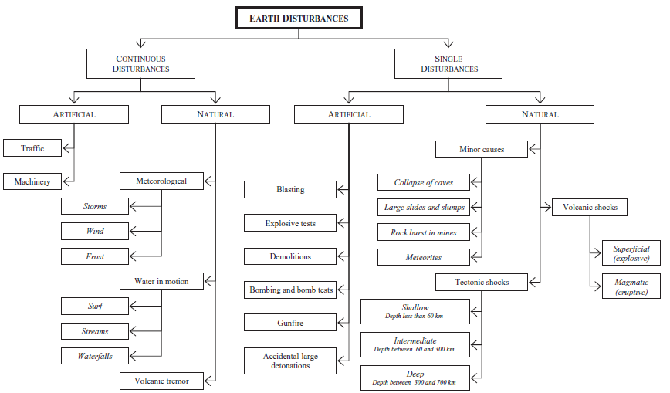
Figure 2 Seismograph Disturbances (Elnashai and Sarno 2008:2)
“Earthquakes are produced by the rapid release of elastic energy stored in rock that has been deformed by differential stresses” (Tarbuck 2011:306). Theses stresses are usually a result of fractures from faults. Months following an earthquake, numerous aftershocks, or small tremors, are likely produced. The most common occurrence of earthquakes will be found near tectonic plate boundaries, as seen in fig. 3. The direction of the conflicting plate movement determines which kind of fault is produced. A normal fault causes the ground to pull apart. A reverse and thrust fault pushes the land into itself, creating an overlap. A strike-slip fault is the result of the plates grinding in parallel directions. Knowing where a structure is built, and the likelihood of an earthquake, will change the building requirements.
Figure 3 Tectonic Plates vs Earthquakes (Elnashai and Sarno 2008:3)
To fully describe a system, every mass particle and its acceleration would need to be known. However, an appropriate substitute would be to represent entire sections or components as individual, lumped masses (Ghosh 2003:3). This process of discretization is called the generalized coordinate approach. To limit the degrees of freedom in the model, we can produce an approximate behavior of a real structure. The difficultly comes into play when accounting for the internal forces acting on a building. These inertia forces are constantly being effected by other inertia forces, which changes the behavior of the exciting motion (Ghosh 2003:2). Although one floor may not be displaced enough to cause damage, the collective movement of several floors can.
Not all buildings respond the same geographically. In particular, different soils will relate different damping coefficients when transferring the motion of an earthquake to the foundation of a building (Ghosh 2003:6-7). Likewise, earthquakes can display different motions and magnitudes. It is important to test several types of ground movement when testing a model. Thankfully, a database on earthquake movement has been collected using accelerograms to apply to our models. Structural design limitations are determined by zoning, site characteristics, occupancy, configuration, structural system, and height. The two major components include the structural configuration and level of occupancy.
Mathematical models, in application, have particular requirements. “Certain key assumptions are common to most analysis models: the structure is assumed to linearly elastic; small deformation theory applies; structural dissipation (damping) is assumed to be viscous or velocity proportional” (Ghosh 2003:23). The 1997 Uniform Building Code requires the following attributes to the models:
- all elements of the lateral-force-resisting system
- stiffness and strengths of all elements that significant to the distribution of forces
- representation of spatial distribution of mass and stiffness of the structure
- effects of cracked sections in concrete and masonry structures
- contribution of panel zone deformations to story drift for steel moment frame structures
All of the aforementioned requirements are clearly intended to promote the accuracy and reliability of a structure’s model. Although a building may not collapse from an earthquake, projecting the damage expected can prevent disastrous results.
Modelling Applications (Ghosh 2003:20)
Stiffness is relevant for small, frequent earthquakes to maintain minimal non-structural damage. This relates the maximum elastic deformity that is allowed in a structure before nonreversible damage occurs. Beyond this deformity, the building begins to yield past its point of return, called plastic deformation. Plastic deformation occurs after the yield strength is reached and relates the strength of the structure. Damage sustained in this range is associated with medium, infrequent earthquakes, where structural repairs can be made. In the event of a rare, more powerful earthquake, collapse prevention measures are taken. The timespan in which severe structural damage can be mitigated is related to the ductility. Ductility is a ratio between the point of yielding and the point of maximum displacement (Elnashai and Sarno 2008:45-47). Typically, a higher strength means more elasticity at the price of plasticity.
- Equivalent lateral-force procedure refers to the lateral displacement of a floor as the seismic waves propagate through the building. This tactic will be implemented in the models mentioned later. By relating entire portions of structure as a single mass, these models become manageable without losing relevancy.
- Modal analysis procedure (also known as response spectrum analysis) is the study of the peak displacement of position or velocity. This would entail finding the natural frequency of each floor of the building. By having N-stories, there will N natural modes to study as seen in fig. 4.
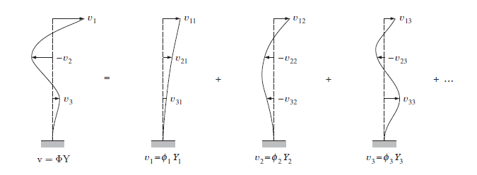
Figure 4 Modal analysis as a linear combination(Kalney 2013)
This means that the entire system’s response is a superposition of all of the natural modes of the system, which are orthogonal. Every position, and therefore velocity and acceleration, can then be related to some scaling of the modal shapes. Each modal shapes has constant proportions the floor interaction. As such, each modal shape can be related to independent, single degree of freedom systems, resulting in an oscillator (MIT OpenCourseWare2013). If the building resembles a similar resonation as the ground, it can amplify the damage similar to whiplash.
- Push-over analysis is testing structural integrity under various stresses. Through a series of nonlinear lateral load tests, a conjecture can be made about the ductility of the structure and the weaknesses of its modal shape. Moreover, this observes the shear strength associated with the materials used for construction. This will not be considered in the models below.
- Inelastic response history analysis involving step-by-step integration of the coupled equations of motion. In the models examined, there will be no translational or torsional motion. This changes the push-over analysis to account for plastic deformities.
Floor Displacement Model
In order to derive the Floor Displacement Model, we must first investigate the Spring-Mass System. Imagine a mass attached to a horizontal spring that is fixed to a stationary support. The mass, when pulled, will cause the spring to oscillate left and right, causing the expansion and compression of the spring’s length. Eventually the mass will slow and become stationary. This resting position is called the equilibrium position. If no other force than gravity is at play, then the mass will remain in that position. To find the position of the mass, at any time, we need to derive an equation relative to the equilibrium position. Recall that Newton’s Second Law of Motion states that the sum of forces (F) acting on an object is equal to the mass (m) of that object multiplied by acceleration (a):
$$\sum{F=ma}$$
Let x(t) represent the position of the mass in meters (m), relative to the equilibrium position. The independent variable time (t) will be in seconds (s). A positive displacement means that the spring has expanded its length and a negative implies contraction. Then the formula can rewritten as
$$\sum{F=m*a}=mx''(t)$$
where acceleration is the second derivative of position, x(t). Mass will be represented measured in kilograms (kg) and force in Newtons (N).
To account for the reduction of the mass’ speed, we need a restoring force. Hooke’s Law states that the restoring force ($F_{s}$) is proportional to the displacement of the mass from its equilibrium position:
$$F_{s}=kx(t)$$
where (k) is the proportionality/spring constant. The spring constant is represented in kilograms per seconds (N/m = kg/s²). However, displacement of the mass causes the restoring to act in the opposite direction:
$$\sum{F=}m\frac{d^{2}x\left(t\right)}{dx^{2}}=-kx(t)$$
However, this is not the only force acting on the mass. To account for the friction of the air or surrounding surfaces, we assume that the resistance force (F_{r}) is proportional to the speed of the mass as kilograms per second (kg/s). The resistance force counteracts movement by applying force in the opposite direction to the velocity of the mass:
$$F_{r}=-cx'(t)$$
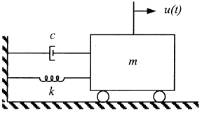
Figure 5 Damped spring mass visualization (Marchand and McDevitt 1999:478)
which is added into the model:
$$m\frac{d^{2}x\left(t\right)}{dx^{2}}=-kx(t)-cx'(t)$$
When there is only one mass, the homogenous differential equation would yield (Chopra 2009:76):
$$x\left(t\right)=x\left(0\right)Cos\left(wt\right)+\frac{x^{'}\left(0\right)}{w_{n}}Sin\left(w_{n}t\right) ;w=\sqrt{\frac{k}{m}}$$
Meaning that the solution had a period length of 2$π$/w_{n}. However, adding the dampening term causes the amplitude to reduce over time. (MIT VIDEO) However, if the dampening is taken into consideration, the amplitude exponentially decays:
$$x\left(t\right)=e^{-c_{n}w_{n}t}(x\left(0\right)Cos\left(w_{n}t\right)+\frac{x^{'}\left(0\right)}{w_{n}}Sin\left(w_{n}t\right))$$
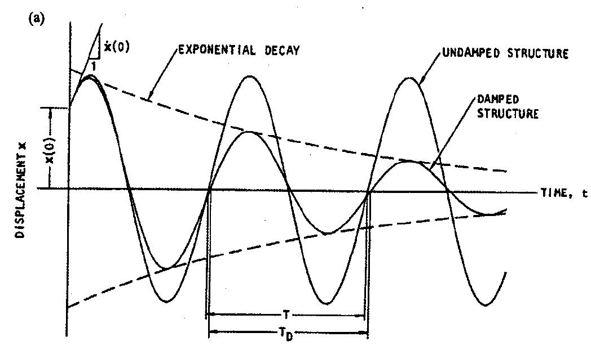
Figure 6 Addition of damping term to an oscillators (Ghosh 2003:43)
To accurately apply this model to a building, the Spring-Mass System should include multiple masses. If another mass is added, then the first and second mass’ positions can be denoted by $x_{1}\left(t\right)$ and $x_{2}\left(t\right)$ respectively. By attaching the second mass to the first by another spring, then these masses will influence each other. If the second mass is pulled to the left, then the right mass’ spring becomes elongated, causing the restoring force to pull to the left as well. Additionally, the relative displacement between masses causes the second mass to influence the first:
$$m_{1}\frac{d^{2}x_{1}\left(t\right)}{dx_{1}^{2}}=-k_{1}x_{1}\left(t\right)+k_{2}(x_{2}\left(t\right)-x_{1}\left(t\right))-c_{1}x_{1}'\left(t\right)+c_{2}({x'}_{2}\left(t\right)-{x'}_{1}\left(t\right))$$
$$m_{2}\frac{d^{2}x_{2}\left(t\right)}{dx_{2}^{2}}=-k_{1}(x_{2}\left(t\right)-x_{1}\left(t\right))-c_{2}(x_{2}^{'}\left(t\right)-x_{1}^{'}\left(t\right))$$
By adding a third spring and mass to the end of mass two:
$$m_{2}\frac{d^{2}x_{2}\left(t\right)}{dx_{2}^{2}}=-k_{2}\left(x_{2}\left(t\right)-x_{1}\left(t\right)\right)+k_{3}\left(x_{3}\left(t\right)-x_{2}\left(t\right)\right) -c_{2}\left(x_{2}^{'}\left(t\right)-x_{1}^{'}\left(t\right)\right)+c_{3}\left(x_{3}^{'}\left(t\right)-x_{2}^{'}\left(t\right)\right)$$
$$m_{3}\frac{d^{2}x_{3}\left(t\right)}{dx_{3}^{2}}=-k_{3}(x_{3}\left(t\right)-x_{2}\left(t\right))-c_{3}\left(x_{3}^{'}\left(t\right)-x_{2}^{'}\left(t\right)\right)$$
Notice that mass two needs to account for the displacement of the mass above and below. By relating a floor of a building as a mass, and the pair of walls as the proportionality/stiffness constant, the Spring Mass System can represent a building restricted to horizontal movement. In this respect, the equilibrium position refers to a building standing perfectly vertical.
Undamped Homogenous Case
Taking what was discussed in the Spring Mass System, a five story building with no damping term can be represented as
$$m_{1}x_{1}^{''}\left(t\right)=-k_{0}x_{1}(t)+k_{1}\left(x_{2}(t)-x_{1}(t)\right)$$
$$m_{2}x_{2}^{''}\left(t\right)=-k_{1}\left(x_{2}(t)-x_{1}(t)\right)+k_{2}\left(x_{3}(t)-x_{2}(t)\right)$$
$$m_{3}x_{3}^{''}\left(t\right)=-k_{2}(x_{3}(t)-x_{2}(t))+k_{3}\left(x_{4}(t)-x_{3}(t)\right)$$
$$m_{4}x_{4}^{''}\left(t\right)=-k_{3}(x_{4}(t)-x_{3}(t))+k_{4}\left(x_{5}(t)-x_{4}(t)\right)$$
$$m_{5}x_{5}^{''}\left(t\right)=k_{4}\left(x_{5}(t)-x_{4}(t)\right)$$
where $x_{1}\left(t\right)$ is the first floor above the ground floor. In its current matrix form (MIT OpenCourseWare 2013):
$$x\left(t\right)=\left[\begin{aligned}x_{1} \\ x_{2} \\ x_{3} \\ x_{4} \\ x_{5}\end{aligned}\right]\left(t\right);M=\left[\begin{matrix}m_{1} & 0 & 0 & 0 & 0 \\ 0 & m_{2} & 0 & 0 & 0 \\ 0 & 0 & m_{3} & 0 & 0 \\ 0 & 0 & 0 & m_{4} & 0 \\ 0 & 0 & 0 & 0 & m_{5}\end{matrix}\right];$$
$$K=\left[\begin{matrix}-\left(k_{0}+k_{1}\right) & k_{1} & 0 & 0 & 0 \\ k_{1} & -\left(k_{1}+k_{2}\right) & k_{2} & 0 & 0 \\ 0 & k_{2} & -\left(k_{2}+k_{3}\right) & k_{3} & 0 \\ 0 & 0 & k_{3} & -\left(k_{3}+k_{4}\right) & k_{4} \\ 0 & 0 & 0 & k_{4} & -k_{4}\end{matrix}\right]$$
M represents the mass at each floor. K represents the stiffness matrix, or the relationship of each floors restoring forces. This model can be abstractly written as MX’’=KX. Notice that there is no ground floor $g\left(t\right)$ represented above. Being homogenous, it is assumed that the ground will never be displaced throughout time, so $g\left(t\right)$ is always at its equilibrium position. Essentially, there is no earthquake in this model, making$g\left(t\right)=0$. Each floor $x_{i}\left(t\right)$ will have an initial displacement: $x_{i}\left(0\right)=c_{i}$. Similarly, each floor will have an initial velocity or rate at which the floor is being displaced: $x_{i}'\left(0\right)=d_{i}$ . This is a system of 2nd order differential equations and, to write in HCP form, substitutions for higher orders need to be made:
$$y_{1}\left(t\right)=x_{1}\left(t\right),y_{2}\left(t\right)=x_{1}^{'}\left(t\right),…,y_{9}\left(t\right)=x_{5}\left(t\right),y_{10}\left(t\right)=x_{5}^{'}\left(t\right)$$
$$y_{1}^{'}(t)=x_{1}^{'}(t)=y_{2}\left(t\right),y_{2}^{'}(t)=x_{1}^{''}\left(t\right),…,y_{9}'\left(t\right)=x_{5}'\left(t\right)=y_{8}(t),y_{10}'\left(t\right)=x_{5}^{''}\left(t\right)$$
where $y\left(t\right)$: [0,$∞) →R^{10}$ and $y_{0}$ is the initial condition vector of positions $c_{i}$ and speed $d_{i}$ :
$$y\left(t\right)=\left[\begin{aligned}y_{1} \\ y_{2} \\ y_{3} \\ y_{4} \\ y_{5} \\ \begin{aligned}y_{6} \\ y_{7} \\ y_{8} \\ y_{9} \\ y_{10}\end{aligned}\end{aligned}\right]\left(t\right) ; y'(t)=\left[\begin{aligned}y_{1} \\ y_{2} \\ y_{3} \\ y_{4} \\ y_{5} \\ \begin{aligned}y_{6} \\ y_{7} \\ y_{8} \\ y_{9} \\ y_{10}\end{aligned}\end{aligned}\right]'\left(t\right); y(0)=y_{0}= \left[\begin{aligned}c_{1} \\ d_{1} \\ c_{2} \\ d_{2} \\ c_{3} \\ \begin{aligned}d_{3} \\ c_{4} \\ d_{4} \\ c_{5} \\ d_{5}\end{aligned}\end{aligned}\right]$$
and A is a 10 x 10 coefficient matrix, where A=M⁻¹K:
A$= \left[\begin{matrix}0 & 1 & 0 & 0 & 0 & 0 & 0 & 0 & 0 & 0 \\ \frac{-(k_{0}+k_{1})}{m_{1}} & 0 & \frac{k_{1}}{m_{1}} & 0 & 0 & 0 & 0 & 0 & 0 & 0 \\ 0 & 0 & 0 & 1 & 0 & 0 & 0 & 0 & 0 & 0 \\ \frac{k_{1}}{m_{2}} & 0 & \frac{-(k_{1}+k_{2})}{m_{2}} & 0 & \frac{k_{2}}{m_{2}} & 0 & 0 & 0 & 0 & 0 \\ 0 & 0 & 0 & 0 & 0 & 1 & 0 & 0 & 0 & 0 \\ 0 & 0 & \frac{k_{2}}{m_{3}} & 0 & \frac{-(k_{2}+k_{3})}{m_{3}} & 0 & \frac{k_{3}}{m_{3}} & 0 & 0 & 0 \\ 0 & 0 & 0 & 0 & 0 & 0 & 0 & 1 & 0 & 0 \\ 0 & 0 & 0 & 0 & \frac{k_{3}}{m_{4}} & 0 & \frac{-(k_{3}+k_{4})}{m_{4}} & 0 & \frac{k_{4}}{m_{4}} & 0 \\ 0 & 0 & 0 & 0 & 0 & 0 & 0 & 0 & 0 & 1 \\ 0 & 0 & 0 & 0 & 0 & 0 & \frac{k_{4}}{m_{5}} & 0 & \frac{-k_{4}}{m_{5}} & 0\end{matrix}\right]$
Yielding the HCP desired form by definition 4.1.1 (McKibben and Webster 2015):
$$y^{'}\left(t\right)=A y\left(t\right);t>0; y\left(0\right)=y_{0}$$
and by theorem 4.6.1 $∀ y_{0}∈R^{10}$, the initial value problem has a unique classical solution:
$y\left(t\right)$ = $e^{A(t-t_{0})}y_{0}$
- This requires that y(t) is right-continuous at t=0 (see Prop. 4.5.3 (ii) (McKibben and Webster 2015) because
$$e^{A(t-t_{0})}∈M^{10}$$
- y(t) is differentiable on (0,$∞)$, satisfying the HCP form listed above (see Prop. 4.5.5 (i))
$$\frac{d}{dt}e^{A(t-t_{0})}y_{0}=e^{A(t-t_{0})}Ay_{0}$$
- And by definition (Prop 4.5.2(i)): y(t) satisfies the initial conditions : y(0) = $y_{0}$
$$y\left(0\right)=e^{A(0)}y_{0}=I_{10}y_{0}=y_{0}$$
If the initial condition is not 0, the corollary 4.6.1 (McKibben and Webster 2015) can be applied. The argument above was specifically for $R^{10}$, but this holds for any finite N$∈$N. For example, if there was a building with n-stories: $y\left(t\right)$: [0,$∞) →R^{2n}$, $A∈M^{2n}$, because of the 2nd order substitutions.
If a parameter was slightly off, the ideal model would also only be slightly perturbed. For this reason, we want the model to become more accurate as the error shrinks. Any error of the initial condition can be represented in another, similarly constructed, vector $δ$. Likewise, any perturbation of the mass or the stiffness can be represented another, similarly constructed, matrix $B_{ε}$. This new system can then be denoted:
$$y_{ε,δ}^{'}\left(t\right)=\left(A+B_{ε}\right)y_{ε,δ}\left(t\right) ,$$
$$y_{ε,δ}\left(t_{0}\right)={ y}_{0}+δ$$
Assuming that $A and B_{ε}$ commute $→e^{A}e^{B_{ε}}$commutes, then it can be shown that
$$0≤limit\left(ε,δ→0\right)\max\left(t_{0},t_{0}+T\right){\left|y\left(t\right)-y_{ε,δ}\left(t\right)\right|}_{R^{N}}≤0$$
by properties of integrals, the triangle inequality, properties of the norm, and the squeeze theorem on some finite interval. Essentially, this asserts that as the error approaches 0, the perturbed solution will converge with the true solution. By converging, the difference of the solutions becomes 0 $∈R^{N}$, which implies that the norm becomes 0.
Example
Using the “MATLAB Linear APC Solver” (McKibben and Webster 2015) provided, I was able to create various models of a 5-story building that did not encounter an earthquake, but still had displaced floors. If no floor had been displaced, then the system would not change from its equilibrium position. With no dampener in place, it is expected that the system will never stop moving by Newton’s First Law of Motion. With an expected mass of 10kg per floor and a stiffness of 5kg/s², A is shown in fig. 7:
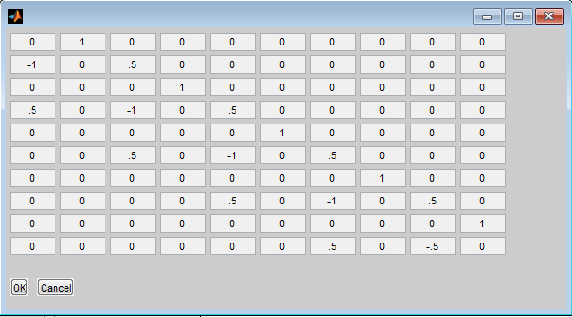
Figure 7 Coefficient matrix for mass and stiffness
I decided the initial velocities to be 0, and the initial floor displacements as {-0.5, 0.5, 1, 0.75, 0.25} meters respectively. The resulting system for t = 20 seconds is shown in fig. 8:
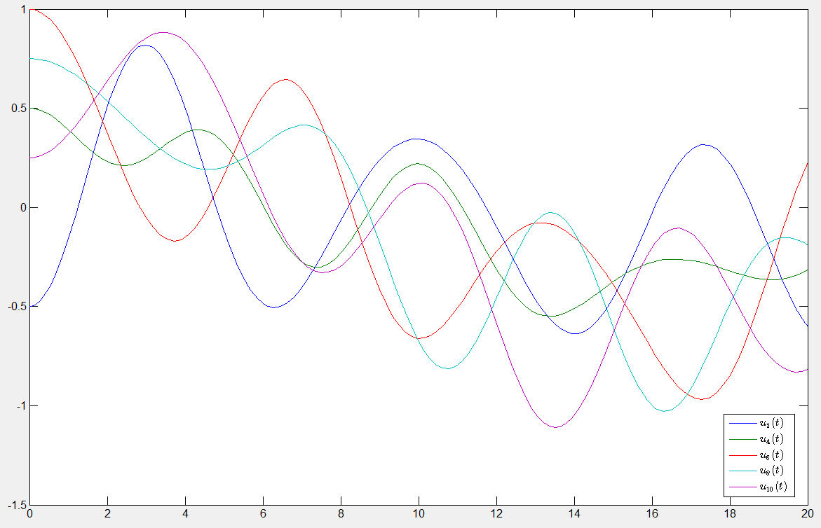
Figure 8 Initially displaced homogenous hodel
Take note of the overall downward shift for each floor’s position. Since the majority of building was displaced in the positive direction, then the building begins to pull back towards the negative direction. Likewise, each floor is being pulled back and forth from the displacement above and below. This will continue to occur in an indefinite, periodic fashion.
Increasing each stiffness coefficient by 50% resulted in a higher frequency for each floor’s periodic movement. Essentially, each floor’s restoring force is acting quicker as seen in fig. 9.
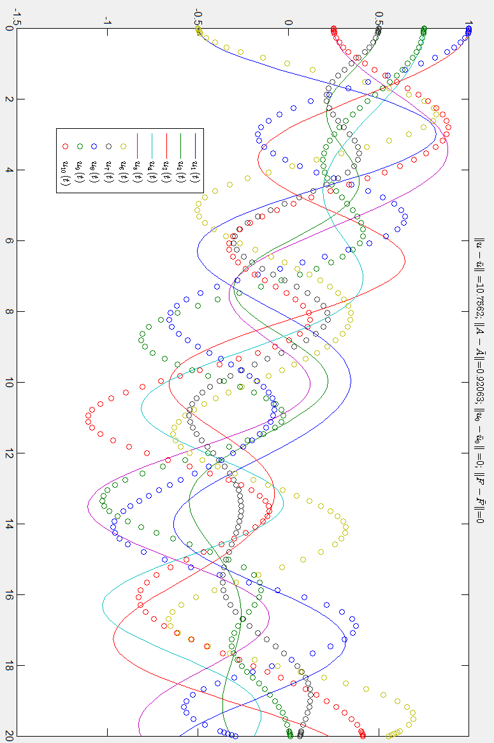
Figure 9 Uniformed increase of stiffness shortens the periodic movement, but not the amplitude.
Similarly, decreasing each stiffness coefficient by 50% resulted in a lower frequency for each floor’s periodic movement, as seen in fig. 10. Each floor is reacting to the displacement at a slower rate. When uniformly changed, this does not change the amplitude or the degree at which each floor is displaced. Perturbing the stiffness only changes the speed at which the exciting energy propagates through the building.
With no dampener, increasing each mass coefficient by 20% uniformly resulted in a longer frequency for each floor’s periodic movement, shown in fig. 11. Essentially, each floors’ displacement has a greater effect with the increase of its force, making the stiffness less effective. Similarly, decreasing the mass by 20% resulted in a higher frequency, seen in fig. 12, because the stiffness was more responsive. Since the ratio of stiffness over mass was maintained, the amplitude or shape was not distorted, only elongated or compressed in periodicity.
Perturbing the initial positions slightly at random, shown in fig. 13, did not cause the solutions to perturb drastically from the original. By randomly adjusting initially 0 velocities, the behavior deviates somewhat differently in fig. 14, but quickly returns to the same general behavior. When the ratio of the stiffness and mass between floors was adjusted, the overall difference was minor in fig. 15. This may be attributed to the periodic nature of both over and under-estimating the position of floors as time progresses. However, this model is hardly realistic without a damping term.
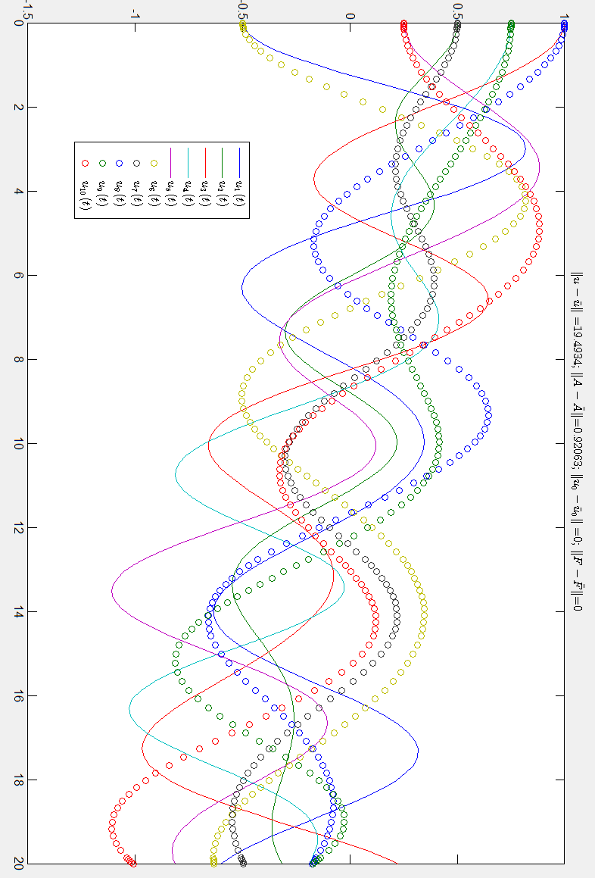
Figure 10 Uniformly increasing stiffness elongates periodic movement, but not the amplitude
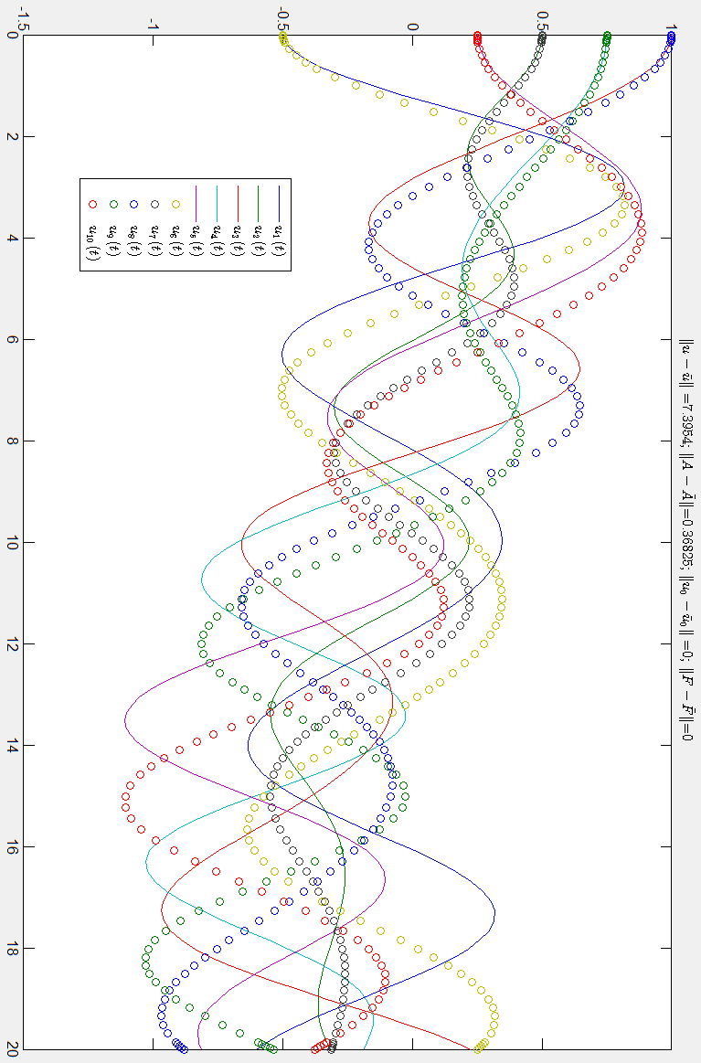
Figure 11 Uniformly increasing mass elongates period movement, but no change in amplitude
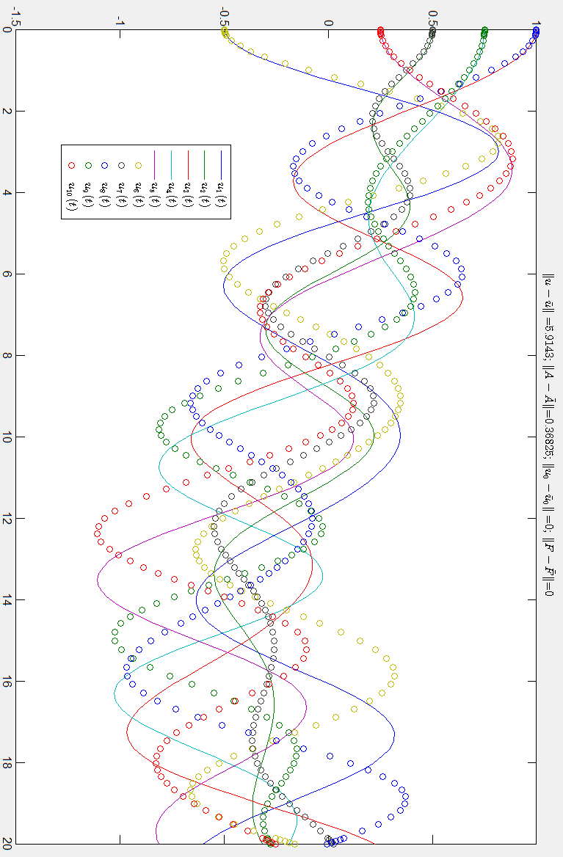
Figure 12 Uniformly decreasing mass shortens the period, but not the amplitude
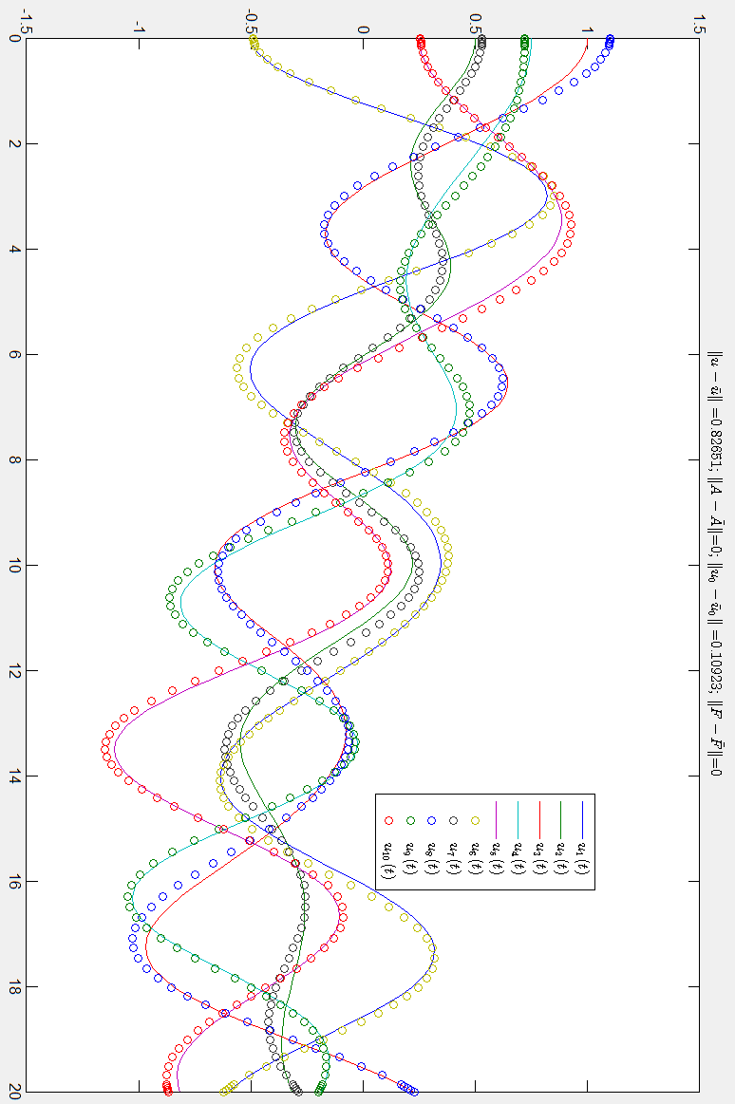
Figure 13 Perturbing the position in a small way will not cause a large deviation from the original solution
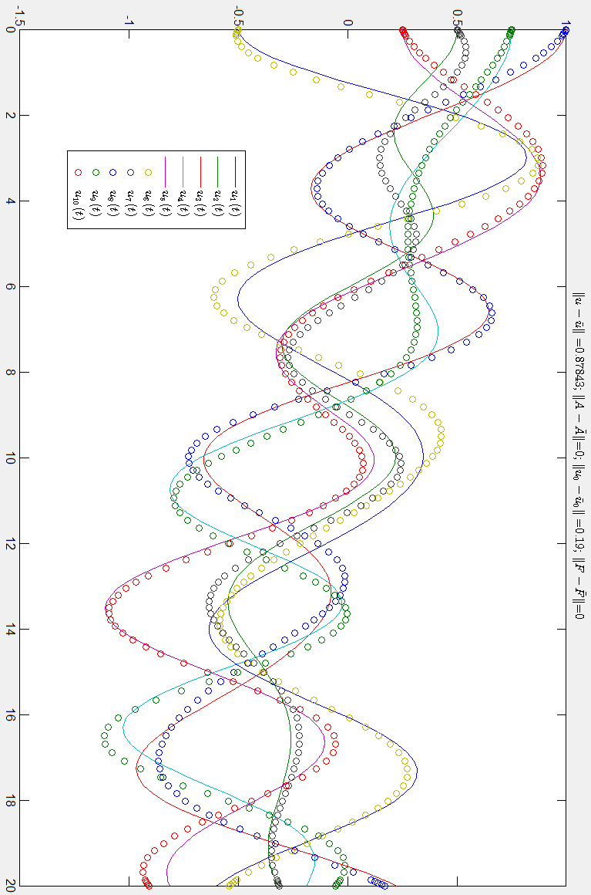
Figure 14 Perturbing the initial velocity in a small way will not cause a great deviation from the original solution
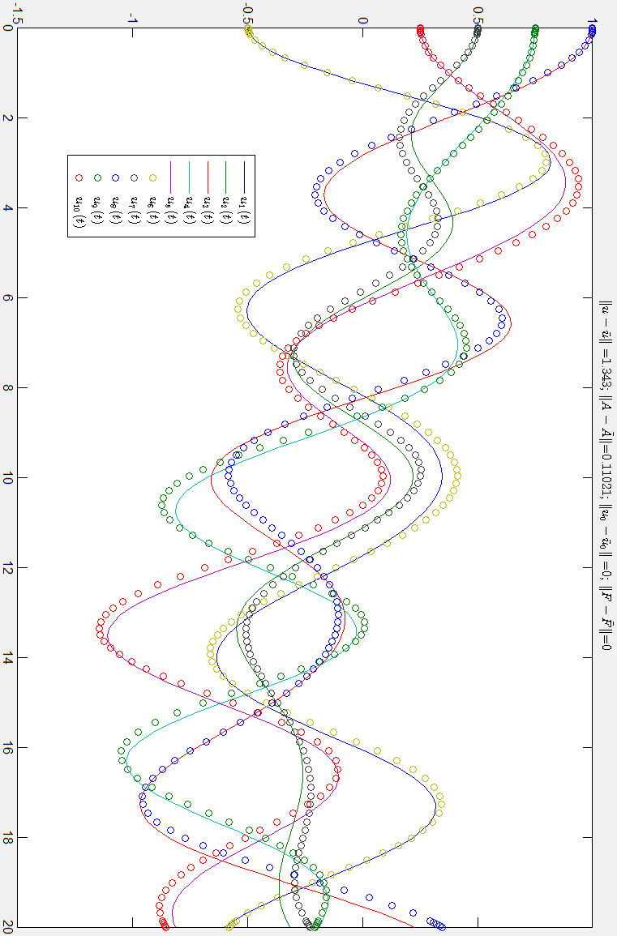
Figure 15 Perturbing the ratio of stiffness and mass between floors in a small way will not cause a great deviation
Damped Homogenous Case
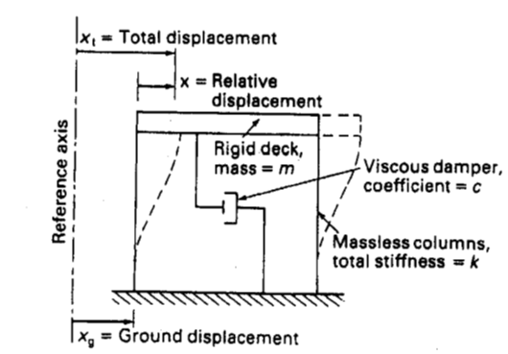
Figure 16 Visualization of building shear and variable representation (Ghosh 2003:42)
Taking what was discussed in the Spring Mass System, a five story building with a damping term can be constructed. The base of the structure is depicted in fig 16, x_{g} = 0.
$$m_{1}x_{1}^{''}\left(t\right)=-k_{0}x_{1}\left(t\right)+k_{1}\left(x_{2}\left(t\right)-x_{1}\left(t\right)\right)-c_{0}x_{1}^{'}\left(t\right)+c_{1}\left(x_{2}^{'}\left(t\right)-x_{1}^{'}\left(t\right)\right)$$
$$m_{2}x_{2}^{''}\left(t\right)=-k_{1}\left(x_{2}\left(t\right)-x_{1}\left(t\right)\right)+k_{2}\left(x_{3}\left(t\right)-x_{2}\left(t\right)\right)-c_{1}\left(x_{2}^{'}\left(t\right)-x_{1}^{'}\left(t\right)\right)+c_{2}\left(x_{3}^{'}\left(t\right)-x_{2}^{'}\left(t\right)\right)$$
$$m_{3}x_{3}^{''}\left(t\right)=-k_{2}\left(x_{3}\left(t\right)-x_{2}\left(t\right)\right)+k_{3}\left(x_{4}\left(t\right)-x_{3}\left(t\right)\right)-c_{2}\left(x_{3}^{'}\left(t\right)-x_{2}^{'}\left(t\right)\right)+c_{3}\left(x_{4}^{'}\left(t\right)-x_{3}^{'}\left(t\right)\right)$$
$${ m}_{4}x_{4}^{''}\left(t\right)=-k_{3}(x_{4}(t)-x_{3}(t))+k_{4}\left(x_{5}(t)-x_{4}(t)\right)-c_{3}\left(x_{4}^{'}\left(t\right)-x_{3}^{'}\left(t\right)\right)+c_{4}\left(x_{5}^{'}\left(t\right)-x_{4}^{'}\left(t\right)\right)$$
$$m_{5}x_{5}^{''}\left(t\right)=k_{4}\left(x_{5}\left(t\right)-x_{4}\left(t\right)\right)-c_{4}\left(x_{5}^{'}\left(t\right)-x_{4}^{'}\left(t\right)\right)$$
$$My^{''}\left(t\right)=Cy^{'}\left(t\right)+Ky\left(t\right)$$
Notice the symmetry between the restoring forces and damping forces. The only difference is that one relates relative position and the other relates relative speed. Similar to before, the construction of the HCP model and the form of its solution are exactly the same. As such, the continuous dependence results still hold, assuming that the error matrix commutes with the matrix product of the stiffness and inverse mass matrices. This same pattern of floor dependency can be extended to the N-story by the same fashion:
$$m_{i}x_{i}^{''}\left(t\right)=-k_{i-1}\left(x_{i}\left(t\right)-x_{i}\left(t\right)\right)+k_{i}\left(x_{i+1}\left(t\right)-x_{i}\left(t\right)\right)-c_{i-1}\left(x_{i}^{'}\left(t\right)-x_{i-1}^{'}\left(t\right)\right)+c_{i}\left(x_{i+1}^{'}\left(t\right)-x_{i}^{'}\left(t\right)\right)$$
$$m_{N}x_{N}^{''}\left(t\right)=k_{N-1}\left(x_{N}\left(t\right)-x_{N-1}\left(t\right)\right)-c_{N-1}\left(x_{N}^{'}\left(t\right)-x_{N-1}^{'}\left(t\right)\right)$$
The coefficient matrix for the 10 by 10 case now resembles:
A$= \left[\begin{matrix}0 & 1 & 0 & 0 & 0 & 0 & 0 & 0 & 0 & 0 \\ \frac{-(k_{0}+k_{1})}{m_{1}} & \frac{-(c_{0}+c_{1})}{m_{1}} & \frac{k_{1}}{m_{1}} & \frac{c_{1}}{m_{1}} & 0 & 0 & 0 & 0 & 0 & 0 \\ 0 & 0 & 0 & 1 & 0 & 0 & 0 & 0 & 0 & 0 \\ \frac{k_{1}}{m_{2}} & \frac{c_{1}}{m_{2}} & \frac{-(k_{1}+k_{2})}{m_{2}} & \frac{-(c_{1}+c_{2})}{m_{2}} & \frac{k_{2}}{m_{2}} & \frac{c_{2}}{m_{2}} & 0 & 0 & 0 & 0 \\ 0 & 0 & 0 & 0 & 0 & 1 & 0 & 0 & 0 & 0 \\ 0 & 0 & \frac{k_{2}}{m_{3}} & \frac{c_{2}}{m_{3}} & \frac{-(k_{2}+k_{3})}{m_{3}} & \frac{-(c_{2}+c_{3})}{m_{3}} & \frac{k_{3}}{m_{3}} & \frac{c_{3}}{m_{3}} & 0 & 0 \\ 0 & 0 & 0 & 0 & 0 & 0 & 0 & 1 & 0 & 0 \\ 0 & 0 & 0 & 0 & \frac{k_{3}}{m_{4}} & 0 & \frac{-(k_{3}+k_{4})}{m_{4}} & \frac{-(c_{3}+c_{4})}{m_{4}} & \frac{k_{4}}{m_{4}} & \frac{c_{4}}{m_{4}} \\ 0 & 0 & 0 & 0 & 0 & 0 & 0 & 0 & 0 & 1 \\ 0 & 0 & 0 & 0 & 0 & 0 & \frac{k_{4}}{m_{5}} & \frac{c_{4}}{m_{5}} & \frac{-k_{4}}{m_{5}} & \frac{-c_{4}}{m_{5}}\end{matrix}\right]$
Example
Using the “MATLAB Linear APC Solver” (McKibben and Webster 2015) provided, I chose the same parameters for mass = 1000kg, stiffness = 5000 kg/s², and I choose the damping term = 500 kg/s. The resulting coefficient matrix is seen in fig. 17: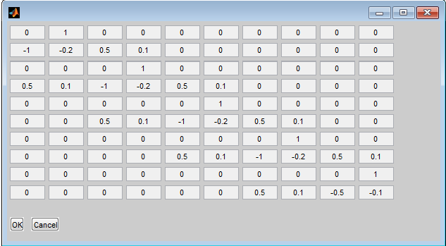
Figure 17 The coefficient matrix for the GUI
The same initial displaced floor positions and velocities were chosen as before, yielding fig. 18. Notice that each floor begins to oscillate with less amplitude as time goes on. However, there are some areas where the exciting motion of several floors collectively pushes one floor further. Fig. 19 looks at an extended time period of 100 seconds:
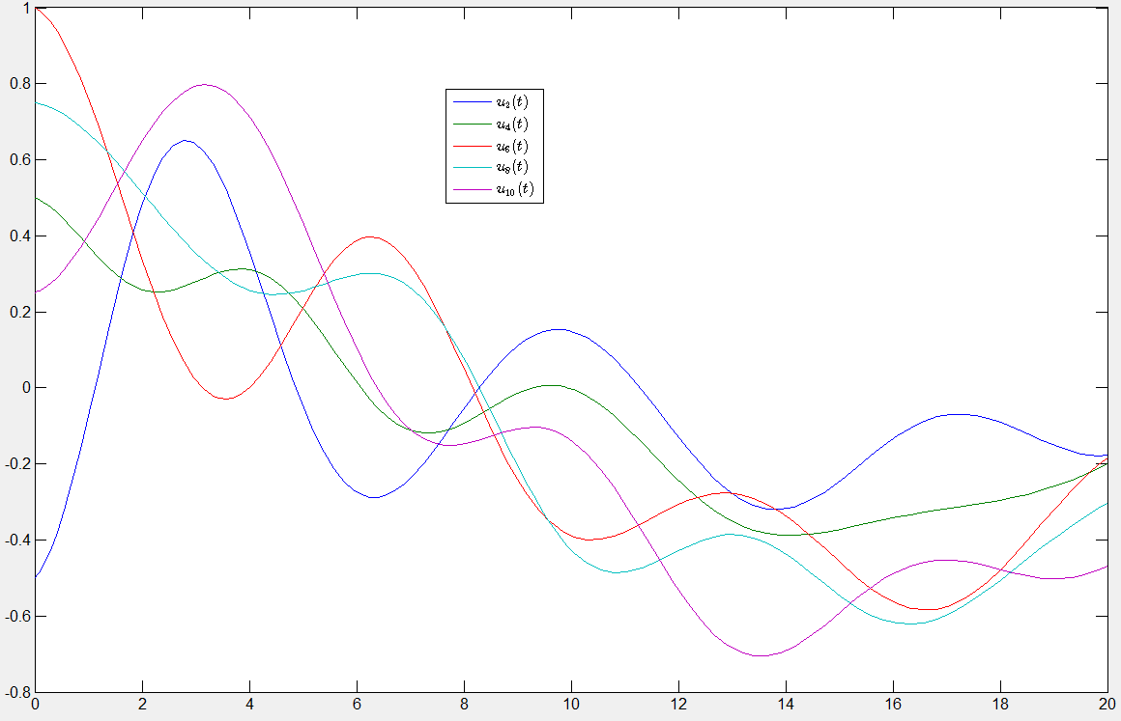
Figure 18 The initial displacement of floors and their damped movements thereafter
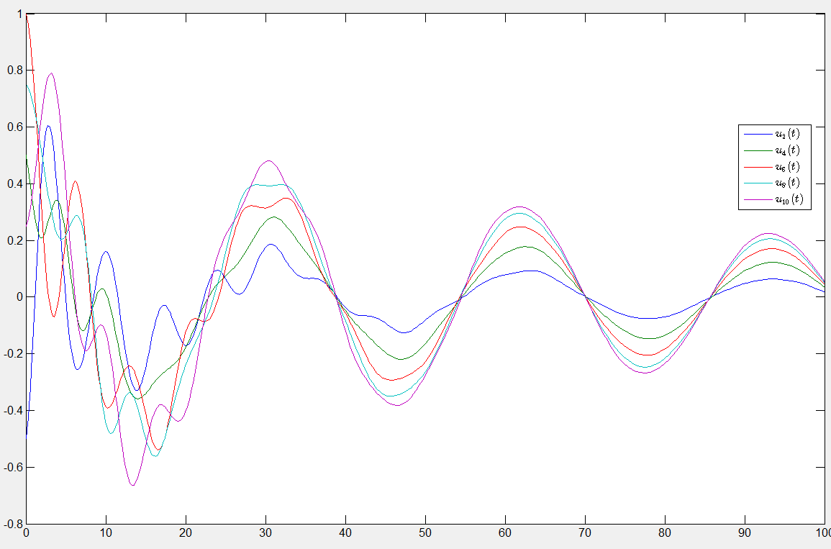Figure 19 An extended look of initially perturbed displacement of a damped system
It appears that the upper floors stop acting in opposite directions, which can be seen in the uniform sinusoidal pattern the building takes. The difference of amplitudes is attributed by the exciting motion of the bottom floor and the transfer of motion from the stiffness between each floor. The overall amplitude of the building continues to degrade, and each floor should return to its equilibrium position. Perturbing the initial position, initial velocity, mass, stiffness, or damping coefficient, in a small way, will not cause the new solution to greatly differ.
Undamped Non-Homogenous Case
Although I created a similar situation in the previous model, no earthquake model would be complete without an earthquake. It will be assumed that there is no damping coefficient with the foundation of the building and the soil as the earthquake perturbs the ground. Additionally, this model will describe the behavior of the building with no damping terms throughout the building. An appropriate assumption would be that the ground floor moves with the earthquake, which we will denote g(t). The coefficient matrix will be identical; the only difference will be the addition of a vector containing each floor’s respective forcing terms. This model only possesses a forcing term on related to the first floor:
$$m_{1}x_{1}^{''}\left(t\right)=-k_{0}(x_{1}\left(t\right)-g(t))+k_{1}\left(x_{2}\left(t\right)-x_{1}\left(t\right)\right)$$
Since the ground floor is not meant to be in the coefficient matrix, we can pull it into the forcing term of the first floor:
$m_{1}x_{1}^{''}\left(t\right)=-k_{0}(x_{1}\left(t\right)+k_{1}\left(x_{2}\left(t\right)-x_{1}\left(t\right)\right)$ $,f\left(t\right)= \left[\begin{aligned}0 \\ \frac{k_{0}g\left(t\right)}{m_{1}} \\ 0 \\ 0 \\ 0 \\ \begin{aligned}0 \\ 0 \\ 0 \\ 0 \\ 0\end{aligned}\end{aligned}\right]$
$$My^{''}\left(t\right)=Ky\left(t\right)+f(t)$$
Note that f : [t₀,$∞)→R^{N}$ when there are N components in the vector. Using the same notation as before, the NON-HCP form is constructed by definition 5.1.1 (McKibben and Webster 2015:219): $$y^{'}\left(t\right)=A y\left(t\right)+M^{-1}f\left(t\right);t>t_{0}; y\left(0\right)=y_{0}$$
This yields a unique classical solution when all of the previous HCP conditions hold and when the forcing vector contains only continuous functions by theorem 5.3.1 (McKibben and Webster 2015:142):
$y\left(t\right)$ = $e^{A(t{-t}_{0})}y_{0}+\int_{t_{0}}^{t}{e^{A\left(t-s\right)}f\left(s\right)ds}$
So long as the conditions are satisfied, this form will work for any system and for any size.
Given the similarity to the HCP form, a similar study of perturbation and continuous dependence would be applicable.
- If every forcing term is continuous on some finite interval [0,T]
- and every forcing term can be bounded above by some error, which we then take the collective supreme value across [0,T] represented as $δ$
- and the coefficient matrix commutes with the error matrix comprised of $ε_{i,j}$,
Then it can be shown that
$$0≤limit\left(∀ε_{i,j}, δ →0\right)\sup\left(0,T\right){\left|y\left(t\right)-y_{ε}\left(t\right)\right|}_{R^{N}}≤0$$
by variation of parameters, properties of integrals, the triangle inequality, properties of the norm, and the squeeze theorem on some finite interval. Essentially, we claim that there is a maximum difference that can be shown on some finite interval. By the maximum error going to 0, the difference of the solutions becomes 0 $∈R^{N}$, which implies that the norm becomes 0.
Example
Using the “MATLAB Floor Displacement” GUI (McKibben and Webster 2015) provided, I was able to create the undamped 5-story building that encountered an earthquake, while initially being in its equilibrium position. Each floor had 10000kg of mass, and each stiffness coefficient was 5000kg/s². I chose the ground to deviate $±$2 meters every $\frac{2π}{3}$ seconds, and shake for 2 seconds in fig. 20:
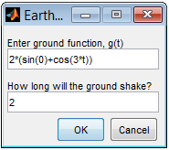
Figure 20 Parameter for forcing term
The system is then observed in fig. 16 for 60 seconds:
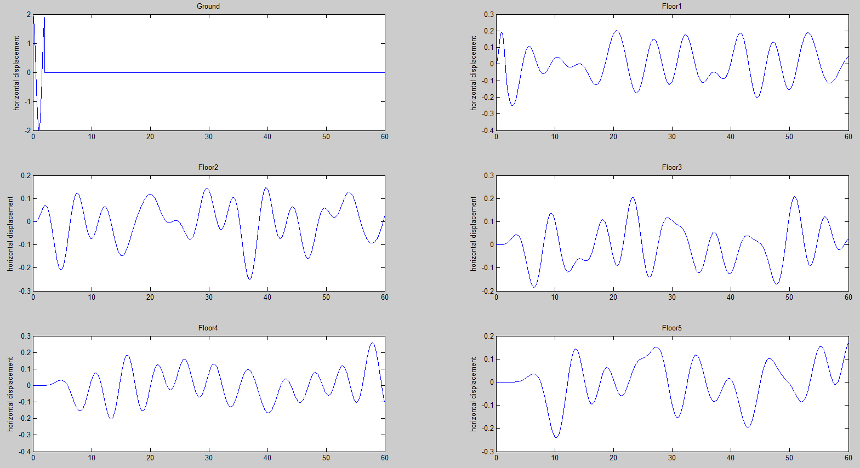
Figure 21 Each floor's movement as time progresses with the ground shaking 2 seconds
Fig 22. observes the building when the ground shakes for 10 seconds:
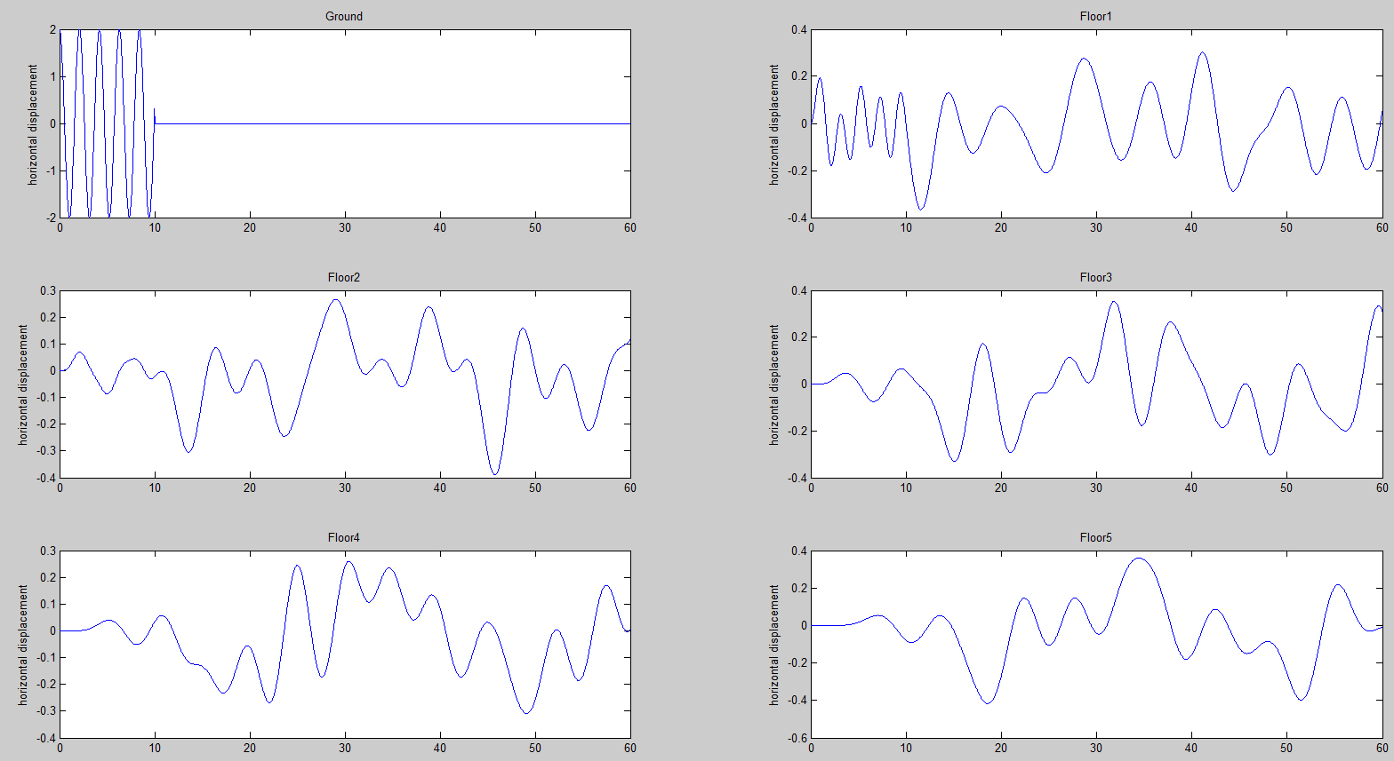
Figure 22 The graph of each floor moving as the ground shakes 6 seconds
Without a damping term, it is expected that the building will never cease its movement from floor to floor. Moreover, by shaking the ground longer, the building acquires more exciting motion to oscillate. If any further perturbation of the ground occurs, it would likely add to the energy of the building in motion. This constant strain and movement would probably cause damage and nausea over time.
Damped Non-Homogenous Case
Using the same damped coefficient matrix as the HCP, this model only adds the forcing vector f(t) for the addition of g(t) as seen in the undamped NON-CP example above. The only change occurs in the first floor:
$$m_{1}x_{1}^{''}\left(t\right)=-k_{0}\left(x_{1}\left(t\right)-g\left(t\right)\right)+k_{1}\left(x_{2}\left(t\right)-x_{1}\left(t\right)\right)-c_{0}\left(x_{1}^{'}\left(t\right)-g^{'}\left(t\right)\right)+c_{1}\left(x_{2}^{'}\left(t\right)-x_{1}^{'}\left(t\right)\right)$$
$$My^{''}\left(t\right)=Cy^{'}\left(t\right)+Ky\left(t\right)+f(t)$$
Naturally, this can be rewritten in NON-CP form, and all of the existence, uniqueness, and continuous dependence results hold. Unfortunately, there is no GUI application that would allow for resistance terms and a finite interval to perturb the ground. However, assuming the ground ceases to shake, then that model thereon would resemble the damped HCP form exactly. This would mean that the system would have initially displace positions and velocities.
Example
Using the “MATLAB Linear APC Solver” (McKibben and Webster 2015) provided, I chose the same parameters for mass = 1000kg, stiffness = 5000 kg/s², and I choose the damping term = 500 kg/s. I chose the vector of forcing terms to be 0, which implies the model is viewing the building after the initial earthquake with initial conditions shown by fig. 23:
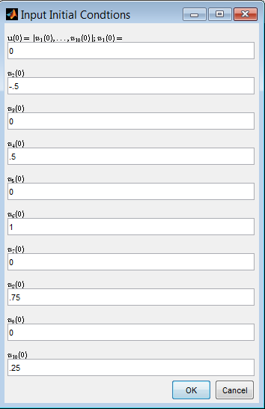
Figure 23 Initial conditions for the GUI
With these initial positions and velocities, the system is observed for 60 seconds in fig. 24:
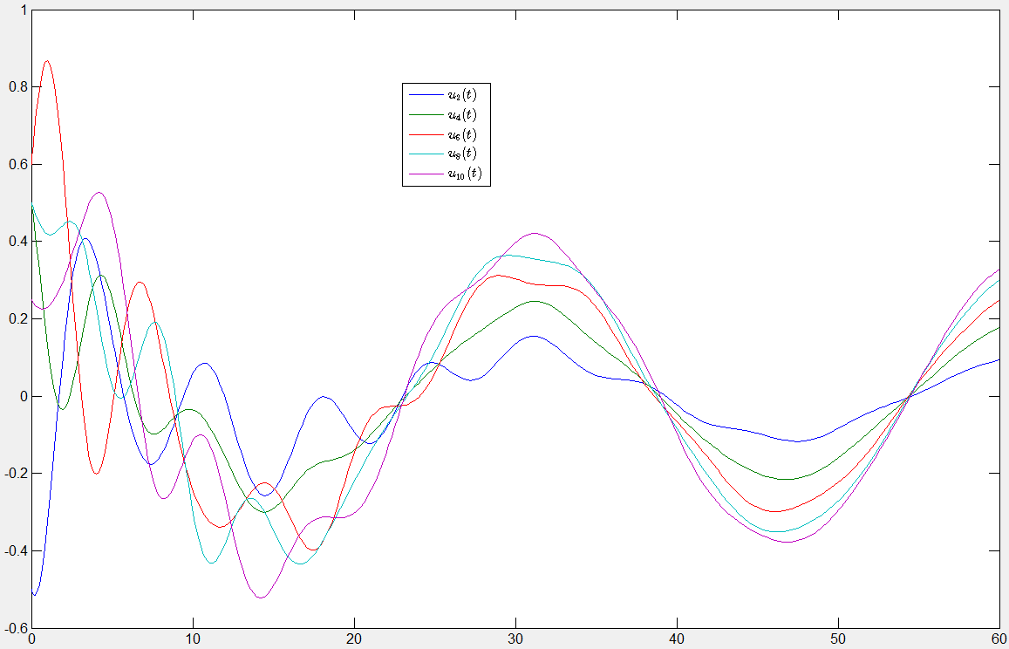
Figure 24 Graph of each floor's position with initially displace positions and velocities
The only difference between this result and the HCP result is the addition of perturbing the initial velocities. Essentially, this means each floor had not yet reached the top of its amplitude for its initial displacement. The system continues to smooth to its equilibrium over time. This means that each floor won’t be drastically opposing each other and the building will eventually halt. Compared to the building that never stops moving, this building is extremely safe.
Semi-Linear Case
The vector of forcing terms is not limited to the movement of the ground. There can be the addition of any outside force that acts over time, such as wind. Additionally, the coefficient matrix does not account for terms of higher degree. When considering a building with nonlinear shock absorbers, each nonlinear team can be accommodated in the respective forcing term. This is important in order to prevent the rapid growth of speed as the floors are displaced. Similar to the previous resistor, these will act in the opposite direction of the velocity. In this model, the damping terms will be proportional to the square of the speed. In order to preserve the direction of velocity, the terms will resemble:
$$-cx^{'}\left(t\right)\left|x^{'}\left(t\right)\right|; c>0$$
When put into the model:
$$m_{1}x_{1}^{''}\left(t\right)=-k_{0}(x_{1}\left(t\right)-g(t))+k_{1}\left(x_{2}\left(t\right)-x_{1}\left(t\right)\right)-c_{0}(x_{1}^{'}\left(t\right){|x}_{1}^{'}\left(t\right)|-g^{'}\left(t\right){|g}^{'}\left(t\right)|)+c_{1}\left(x_{2}^{'}\left(t\right)|x_{2}^{'}\left(t\right)|-x_{1}^{'}\left(t\right){|x}_{1}^{'}\left(t\right)|\right)$$
This pattern would persist until the top floor:
$$m_{N}x_{N}^{''}\left(t\right)=-k_{N-1}(x_{N}\left(t\right)-x_{N-1}\left(t\right))-c_{N-1}(x_{N}^{'}\left(t\right){|x}_{N}^{'}\left(t\right)|-x_{N-1}^{'}\left(t\right)|x_{N-1}^{'}\left(t\right)|)$$
These nonlinear terms are then brought into the vector of forcing terms:
$$M^{-1}f\left(t\right)= \left[\begin{aligned}0 \\ \frac{-c_{0}\left(x_{1}^{'}\left(t\right){|x}_{1}^{'}\left(t\right)\left|-g^{'}\left(t\right){|g}^{'}\left(t\right)\right|\right)+c_{1}\left(x_{2}^{'}\left(t\right)|x_{2}^{'}\left(t\right)|-x_{1}^{'}\left(t\right){|x}_{1}^{'}\left(t\right)|\right)}{m_{1}} \\ ⋮ \\ 0 \\ \frac{{-c}_{N-1}\left(x_{N}^{'}\left(t\right){|x}_{N}^{'}\left(t\right)\left|-x_{N-1}^{'}\left(t\right)\right|x_{N-1}^{'}\left(t\right)\right)}{m_{N}}\end{aligned}\right]$$
$$y^{''}\left(t\right)=Ay\left(t\right)+M^{-1}f(t,y(t))$$
Now each forcing term can potentially have a function of t and/or a function of x_{i}(t). The coefficient matrix would then only be the product of the inverse mass matrix and the stiffness matrix, as seen in the undamped HCP case. Using the same notation as before, the SEMI-CP form is constructed by definition 7.1.1 (McKibben and Webster 2015:165): $$y^{'}\left(t\right)=A y\left(t\right)+M^{-1}f\left(t,y\left(t\right)\right);t>t_{0}; y\left(0\right)=y_{0}$$
By theorem 7.6.1, there is a unique mild solution given by:
$y\left(t\right)$ = $e^{A(t-t_{0})}y_{0}+\int_{t_{0}}^{t}{e^{A\left(t-s\right)}f\left(s\right)ds};0≤t≤T$
This model would slow the building a lot more than the previous damped models when the floors are moving rapidly. If the building only gradually changes, then the squared velocities will be less effective. Small perturbations to a building will probably be handled by the natural frequency of the structure, keeping in the range of its elasticity. It is when large, dynamic changes occur that the structure is in peril. I would consider the nonlinear shock absorbers to be invaluable in deflecting large deformations and increasing the ductility of the structure. In the event of an earthquake, a brittle building could potentially collapse without advanced warning.

References
Chopra, A. K., (2009), Dynamics of Stuctures (3rd ed.), New Delhi, India: Pearson
Elnashai, A. S., Sarno, L. D., (2008), Fundamentals of Earthquake Engineering, West Sussex, United Kingdom: Wiley.
Ghosh, S. K., (2003), Seismic Design Using Structural Dynamics (2000 IBC), Country Club Hills, IL: International Code Council.
Kalny, O., (2013), Modal Analysis, available at: https://wiki.csiamerica.com/display/kb/Modal+analysis.
Marchand, R., McDevitt, T. J., (1999), “Learning Differential Equations by Exploring Earthquake Induced Structural Vibrations: A Case Study,” International Journal of Continuing Engineering Education and Life-Long Learning, 6, 477-485.
McKibben, A. M., and Webster, M. D., (2015) Differential Equations with MATLAB, New York: CRC Press.
MIT OpenCourseWare, (2013), “Modal Analysis Orthogonality, Mass Stiffness, Damping Matrix,” available at: https://www.youtube.com/watch?v=OxcCPTc_bXw.
Tarbuck, E. J., (2011), Earth an Introduction to Physical Geology (10th ed.), Upper Saddle River, NJ: Pearson Education.

