**Manager Graduate Degree Reimbursement (MGDR) Program**

At the start of the graduate/doctoral program:

* Submit a [Preapproval](https://wcupa.sharepoint.com/sites/AF/HR/Forms/Shared%20Documents/MgrGradTuition_PreApproval_FillableTemplate.pdf) form for the program or course(se) to your supervisor for approval (requesting approval for the entire program is recommended).
* Send completed Preapproval to [jwhitcomb@wcupa.edu](mailto:jwhitcomb@wcupa.edu).

At the start of each semester:

* Ensure you have a completed [Preapproval](https://wcupa.sharepoint.com/sites/AF/HR/Forms/Shared%20Documents/MgrGradTuition_PreApproval_FillableTemplate.pdf) form for the program.
* Complete the Employer Reimbursement Program application at: <https://www.wcupa.edu/_information/AFA/Fiscal/Bursar/forms/erpApplication/login.aspx> and fill it out for each semester separately.
  + Remember to use [jwhitcomb@wcupa.edu](mailto:jwhitcomb@wcupa.edu) as the Employer Contact, which will route it to me for review and approval that you are eligible to participate in the program.
* This approval will trigger Bursar’s Office to put a “hold” on your tuition and tech fee *only* and the rest of the fees are your responsibility before the semester starts (general fees, etc.).  This “hold” will be released at the end of the semester and you will receive an updated notice of a balance.

At the end of each semester (If you have a grade of B or better):

* Submit the following together as a single PDF to [jwhitcomb@wcupa.edu](mailto:jwhitcomb@wcupa.edu) for review, approval, and submission to Accounts Payable for payment:
  + (1) completed AND SIGNED [Payment Request](http://wcupa.sharepoint.com/sites/af/finance/forms/PRF/SitePages/Home.aspx) in the total amount of the tuition and tech fee,
    - Make sure you select Employee for Payee Type and under Payment Reason, use Manager’s Graduate Degree Reimbursement and the budget information will automatically populate the form.

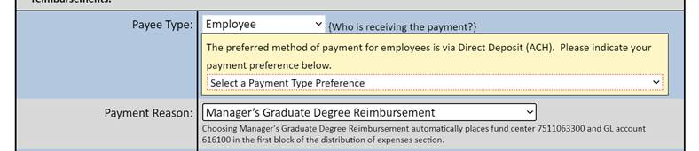

* + (2) copy of approved [Preapproval](https://wcupa.sharepoint.com/sites/AF/HR/Forms/Shared%20Documents/MgrGradTuition_PreApproval_FillableTemplate.pdf) form for program or semester,
  + (3) WCU detailed bill from Bursar, and
  + (4) final grade(s).
* Depending on your payment selection, you will receive an ACH (recommended) or check.
* The last step is for you to pay the semester tuition and tech fee back to the WCU Bursar once the holds have been released.

[CLICK](http://wcupa.sharepoint.com/sites/af/HR/Policies1/Managers%20Graduate%20Tuition%20Reimbursement%20Policy.pdf) to see the actual MGDR policy.

Any questions about these instructions or the process, please contact [jwhitcomb@wcupa.edu](mailto:jwhitcomb@wcupa.edu) or call 610.436.3370.